03-Chatbot-Instructions

Step1 : Navigate to the following location in the shared folder
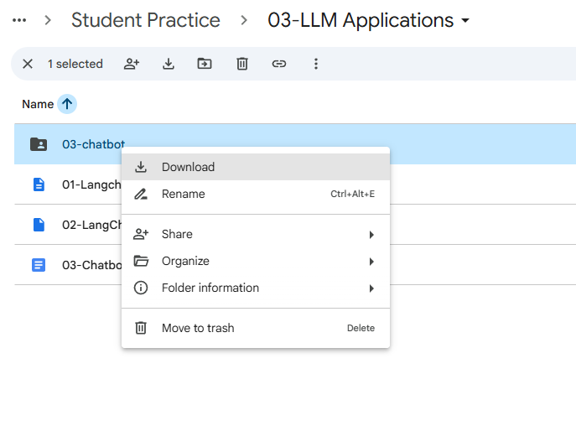

Step2 : Download the 03-charbot folder to your local machine

Step3: Navigate to the download location and unzip the downloaded folder

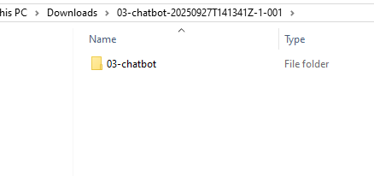

Step 4: Copy this folder to your project location for example
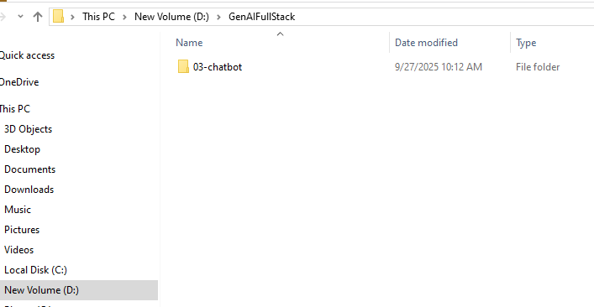

Step 5: Open the 03-charbot project folder from Visual Studio
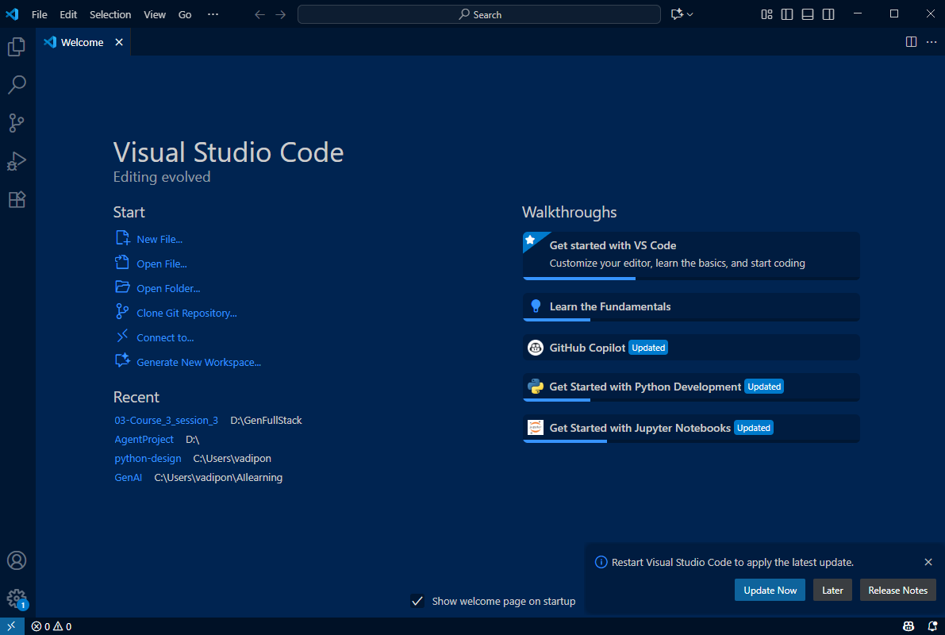
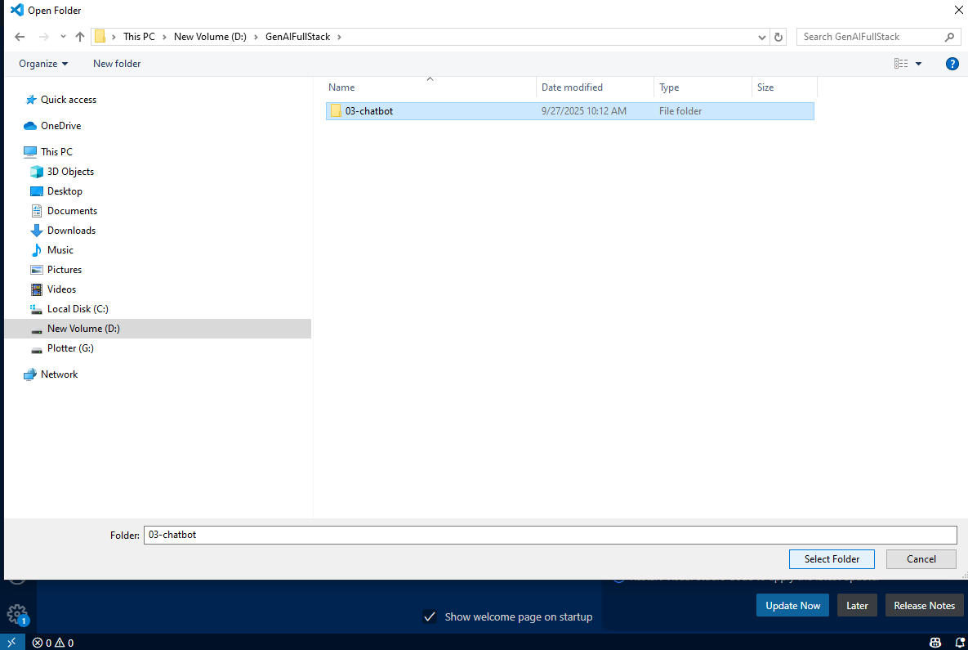
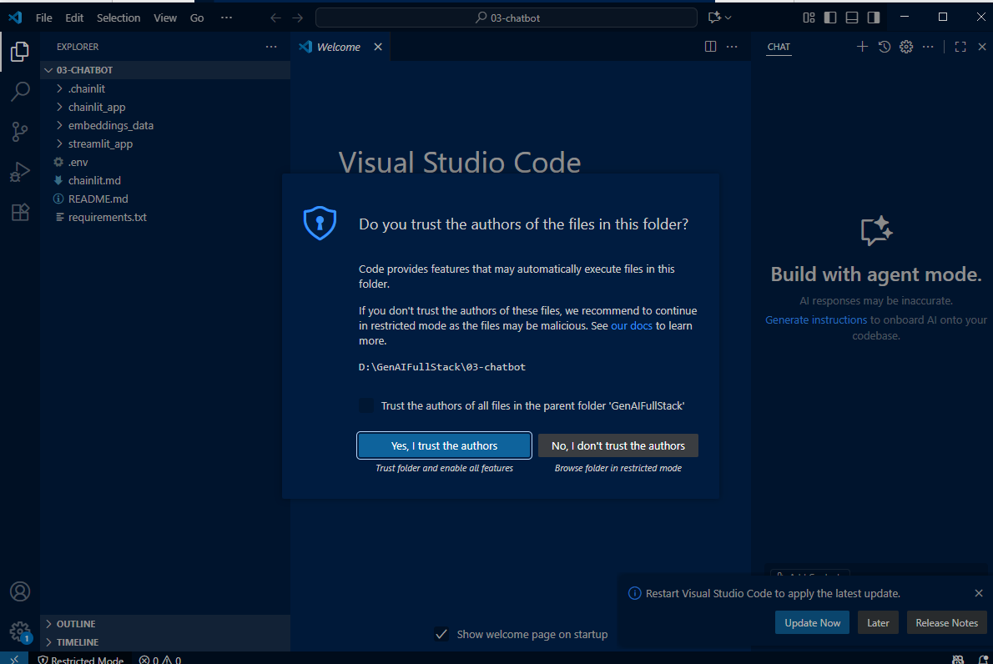
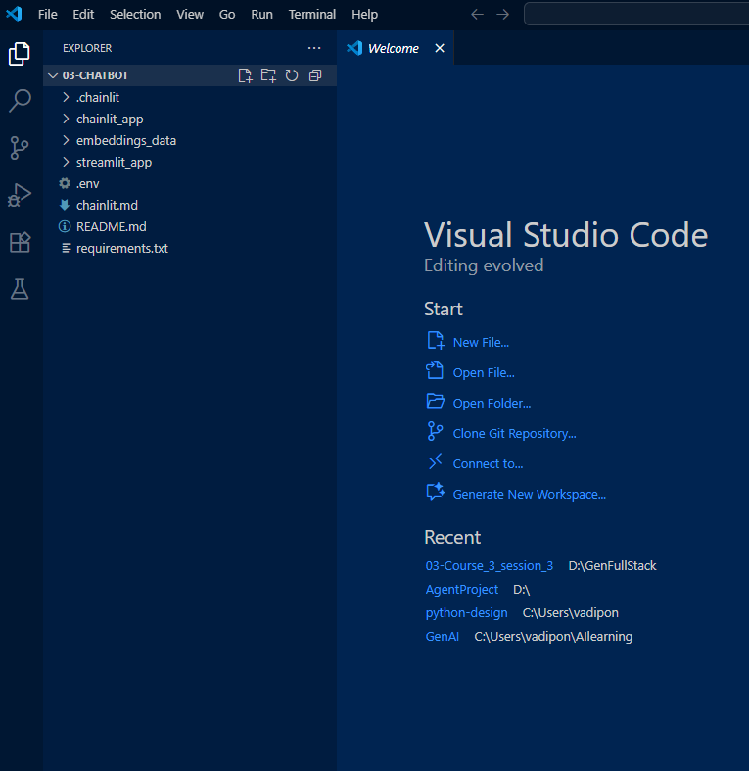

Step 5: Browse the folder from the EXPLORER and familiarize with the content, next we will run the app.py
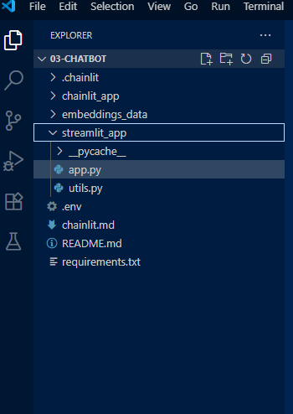

Step 6: Open Terminal window with in the VisualStudio
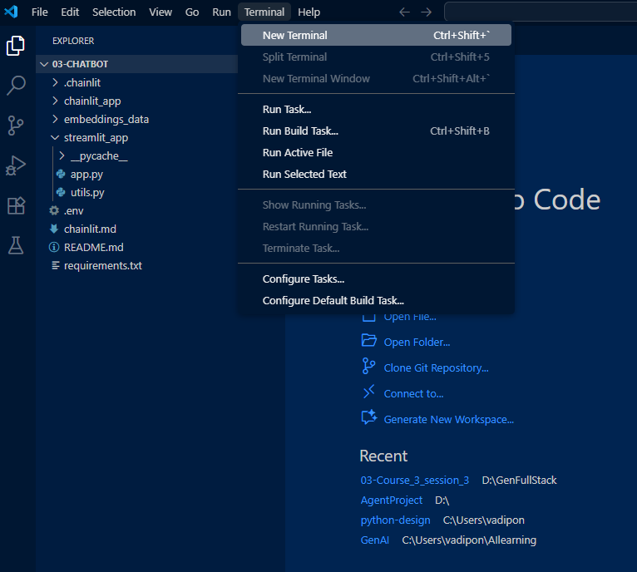

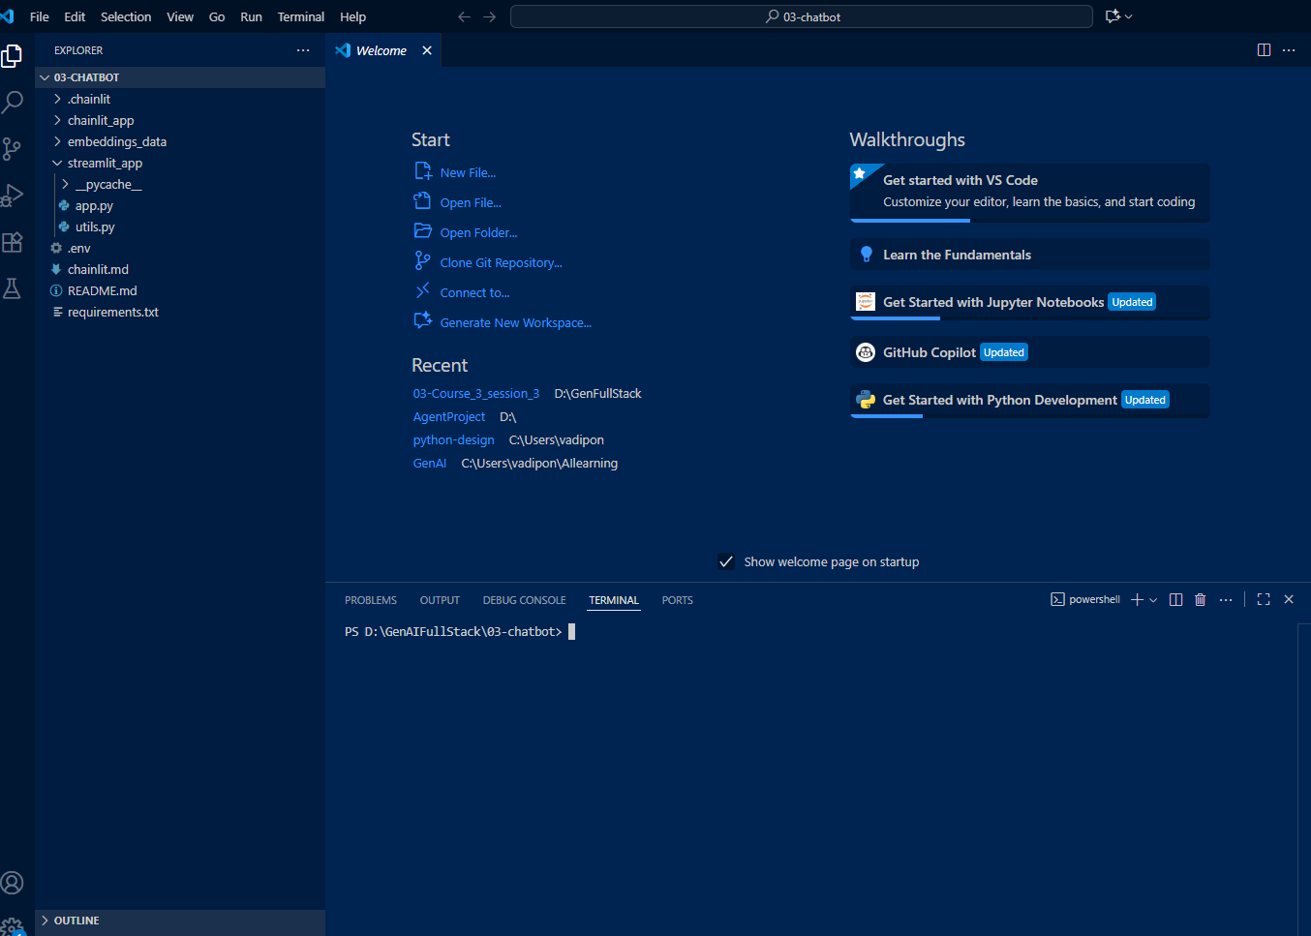

Step 7: use dir command to view the files within the folder and you should see the requirements.txt file.
Use ls-ltr command in case of MAC

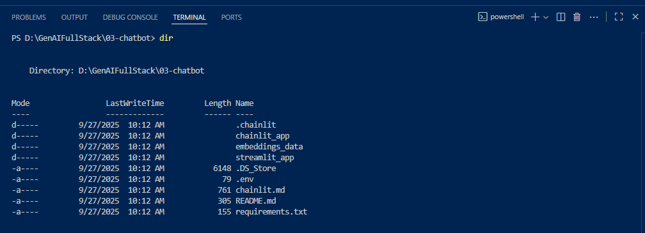

Step 7: Run the following command to install the required libraries for the project

pip install -r requirements.txt

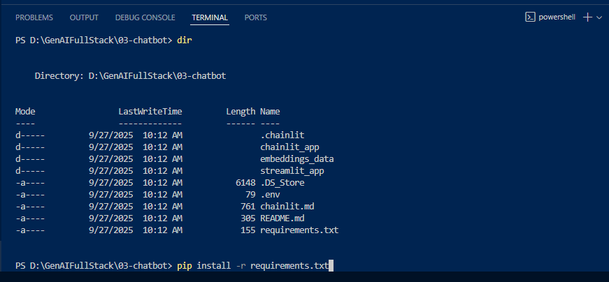

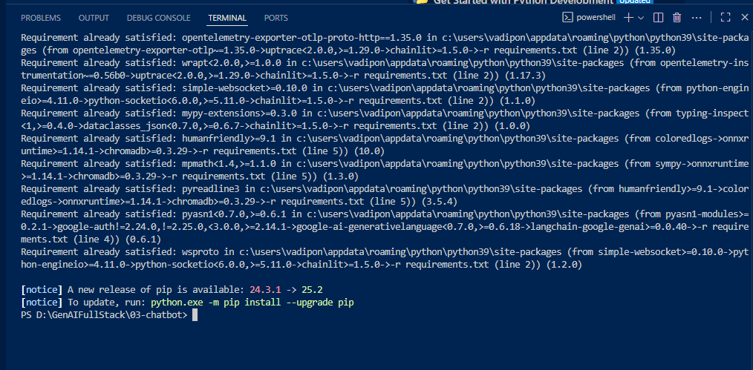

Step 8: Run the following command to launch the app

python -m streamlit run streamlit_app\app.py

In case of MAC

python -m streamlit run streamlit_app/app.py
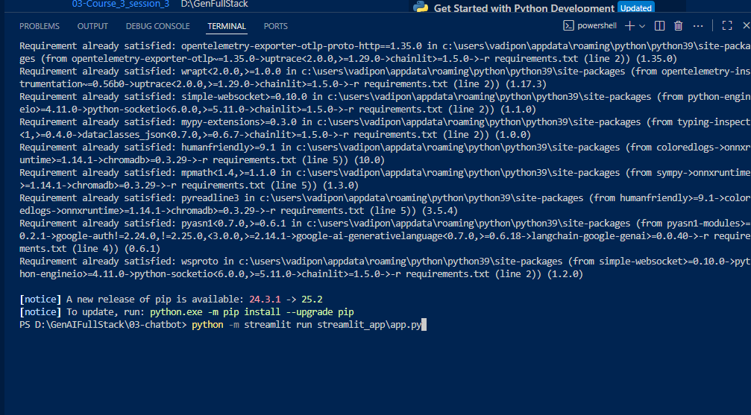
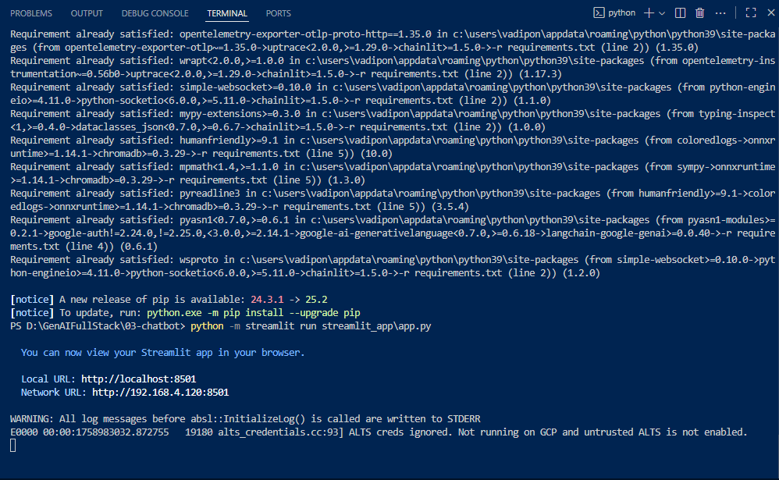

This should Automatically launch your default browser
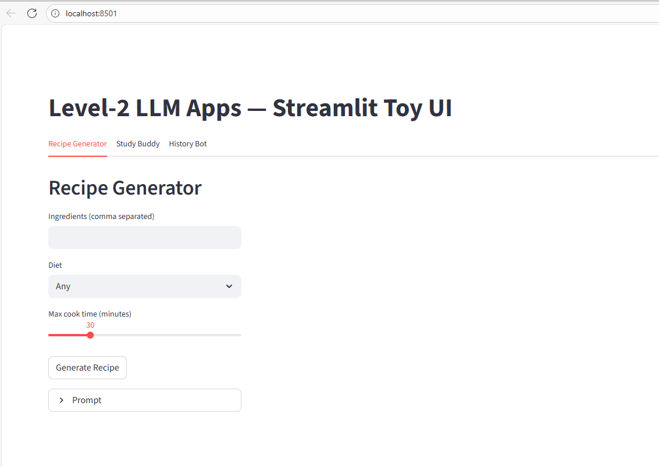

Step 9: Explore the Chat application
